**Assignment IU 05-3 Submission**

Dataset: Automobile price

Deploying machine learning models to managed online endpoints is a critical step in the machine learning lifecycle, enabling real-time predictions in applications. In this context, deploying an MLflow model in Azure Machine Learning is both efficient and user-friendly. Here's the key point and its importance:

Importance:

**Real-Time Predictions:** Deploying a model to an online endpoint allows applications to make real-time predictions. This is vital for scenarios like fraud detection, recommendation systems, and health monitoring where timely decisions are crucial.

**Seamless Deployment:** Deploying an MLflow model simplifies the deployment process. You don't need to define the environment or create a custom scoring script, which can significantly reduce deployment time and complexity.

**Managed Endpoints:** Azure Machine Learning provides a managed environment for deploying and monitoring models, ensuring high availability, scalability, and reliability of the deployed models.

**Testing and Validation:** Before deploying a model to production, you can test it on sample data to ensure it performs as expected. This step is vital to catch any issues early and ensure the model is suitable for real-world applications.

**Resource Cleanup:** At the end of the exercise, you have the option to delete Azure resources. This is an important best practice to avoid unnecessary Azure costs and resource clutter. Azure makes it straightforward to clean up and manage resources efficiently.

**Azure Machine Learning:** Leveraging Azure Machine Learning for model deployment simplifies the process, and you can integrate your deployed models with other Azure services and tools for further data analytics and management.

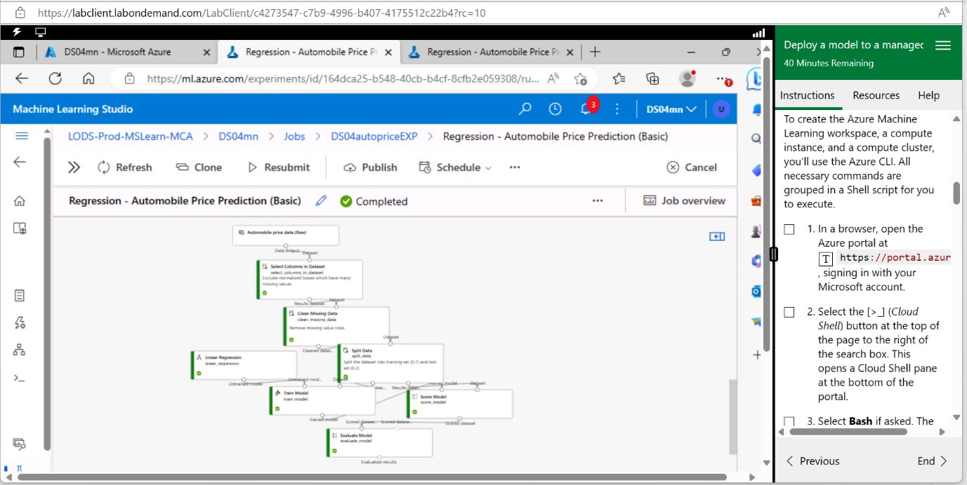

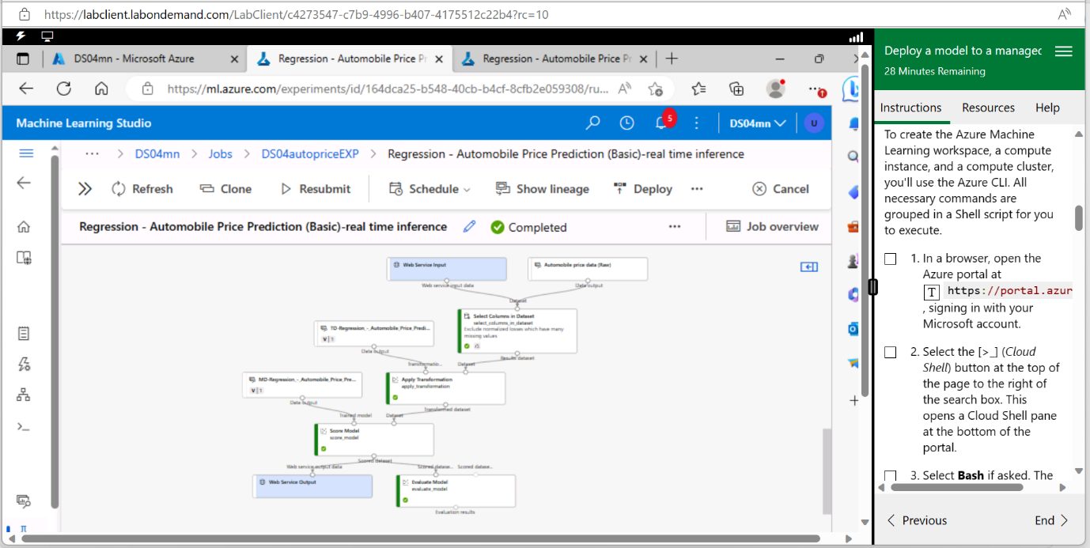

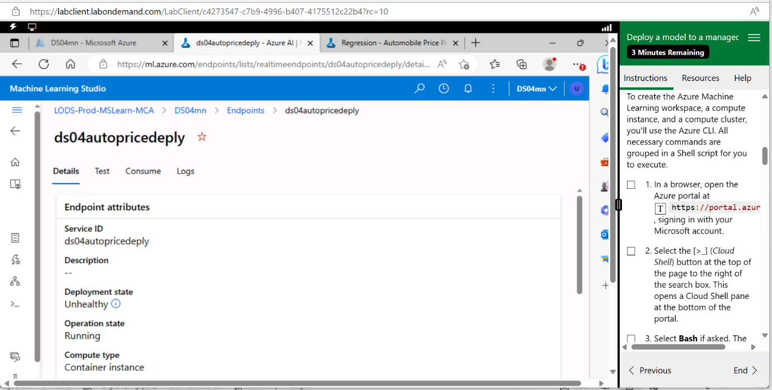

In summary, deploying machine learning models to managed online endpoints is essential for integrating predictive analytics into applications and services. The ease of deploying MLflow models in Azure Machine Learning simplifies the process, and testing on sample data ensures model performance. Additionally, resource cleanup is a crucial step to manage costs and maintain a tidy Azure environment.